

ECEN 5823 IoT Embedded Firmware

Final Course Project

# **Home Automation**

* Tim Chien’s report -

Project members:

- Santhosh thummanapalli

- Tim Chien

**Home Automation using Bluetooth Mesh**

**Summary**

1. ***Problem this project addresses:***

This project is aimed at successfully implementing a smart home model using the Bluetooth client-server architecture. With the advent of technology, the conventional homes are being transferred into smarter ones. In normal day to day life, the energy consumption in a house and safety of the house play a critical role. In our busy life, we forget to switch of the light or air conditioner and we may be faced with fire issue in our house but we may be unable to address them immediately. So, this application implements a smart home which saves energy and address safety concerns. (only fire alarms)

1. ***How it solves them:***

This project tries to implement a smart home which saves energy and implements a smart fire warning system. This project solves the problem of the high current consumption by the existing fire alarms. This is done by using low power energy model approach. For example, the values are obtained from the smoke sensor at interval of 1 second or based on the temperature and humidity values. In this project, the light bulbs are only turned on when a person is present in the room and if the light level decreases in the room.  Thus, this leads to energy conservation. The approaches are explained in detail in the below working model.

1. ***Individual project with any additional detail including implementation plan:***

Friend module (Blue Gecko board) with two presence sensors (IR beam sensor)

* + Server model is responsible to receive two kinds of request from client model node (LPN), Smoke alert (Generic On/Off) Client model and Lightness (Generic Level) Client model.
    - * Lightness value will be showed on LCD in every 5 sec.
      * Smoke alert will be showed on LCD if its value overpasses the threshold value.
  + This node will send room state on/off request to server node while the room state changes, and show room state or number of people in room on LCD.
    - * If “get in” event is triggered, the value of people count will increase, LED0 will turn on, and room state will be set as 1.
      * If “Go out” event is triggered, the value of people count will decrease.
      * If count of people becomes zero, LED0 will turn off, and room state will be set as 0.
  + This node also uses the temperature sensor to control window state
    - * If temperature value is higher than 30 degree Celsius, open the window

Pins usage in Friend node

Two IR Beam sensors:

GND, 5V, GPIO PortD pin 10 and PortA Pin 3

LED0:

GPIO PortF Pin 4

Temperature sensor:

I2C SCL PortC Pin 10 & SDA PortC Pin 11, GPIO PortD Pin 15

***Functional block diagram of the individual project:***

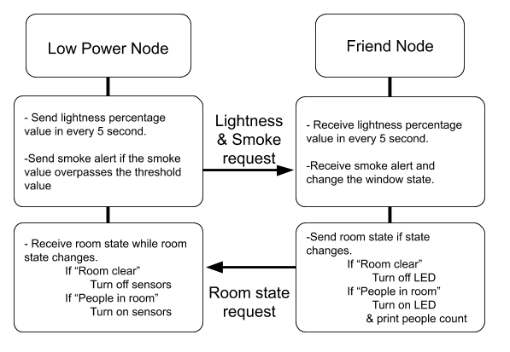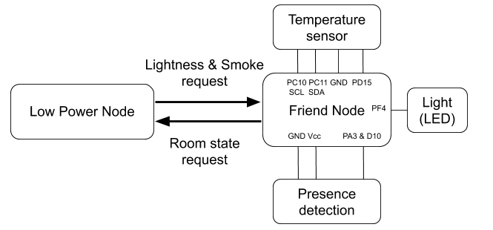

1. ***Bluetooth Commands [Attached excel sheet]***
2. ***List of sensors for this project***
   * + - IR Break Beam Sensor - 5mm LEDs (X2)

<https://www.adafruit.com/product/2168?gclid=EAIaIQobChMI3pKvg8qc4QIVibjACh3DfwLNEAkYBiABEgI5CPD_BwE>

* + - * LED0 – used to demonstrate room state
      * Temperature sensor (Si7021)

1. ***What exposed services and client profiles were implemented?***

Receive Generic On/Off and Lightness client models from LPN

* + - * On/Off model: Smoke alert on and off.
      * Lightness model: Brightness level value.

Send Generic On/Off server model to LPN:

* + - * On/Off model: Room state on and off.

1. ***Persistent Data Used***

The lightness value, room state, window state will be saved to flash memory when those state or value are changed. If Friend node is closed or power shut down with a short time, those persistent data can be called back in Friend node initialization procedure.

1. ***Friend Node Development Schedule***

|  |  |
| --- | --- |
| **Friend Node** | **Complete date** |
| Sensors selection | 4/15/2019 |
| Friend Node (without sensors) | 4/16/2019 |
| Connect with Low Power Node | 4/20/2019 |
| Presence detection (Friend node sensor) | 4/22/2019 |
| Persistent data load and store | 4/27/2019 |
| Test | 4/27/2019 |

1. ***Lessons learnt:***
2. Using I2C and state machine to control temperature sensor.
3. Configuration of mesh communication (Client model publish and receive)
4. Utilizing the persistent data storage and load API functions.
5. learning how to use a new sensor (Ambient light sensor, IR Beam)

***Friend Node* *Verification plan***

**FRIEND NODE WORKING TEST**

|  |  |  |  |  |  |  |
| --- | --- | --- | --- | --- | --- | --- |
| **Sr**  **No** | **To be verified** | **Tester need to do** | **Test date** | **Tested by** | **Tester should see** | **Passed** |
| 1 | provisioning | Turn on power, and use phone app to provision Friend node | 4/20 | Tim | -FN LCD updates to show "Provisioned" | Yes |
| 2 | Friendship establishment | Wait for LPN provisioning. Once both two nodes are provisioned, friendship establishment will start. | 4/20 | Tim | if friendship established, -FN LCD shows "Friend" else -FN LCD shows "no friend” | Yes |
| 3 | is it able to send values with client request | FN will receive brightness value in every 0.5 second, and smoke on/off state if this value overpasses the threshold. | 4/20 | Tim  Santhosh | - FN LCD shows  "LUX value: xx"  "smoke alert!" - FN LCD shows  "model received" | Yes |
| 4 | Check the persistent data | Turn off and on the board and check the persistent value | 4/27 | Tim  Santhosh | - FN terminal shows  "Lightness value: xx"  “Room state: x"  "Window state: x" | Yes |

**IR BEAM TEST**

|  |  |  |  |  |  |  |
| --- | --- | --- | --- | --- | --- | --- |
| **Sr**  **No** | **To be verified** | **Tester need to do** | **Test date** | **Tested by** | **Tester should see** | **Passed** |
| 1 | Presence detection | Wave hand to trigger the IR beam sensor in order | 4/26 | Tim  Santhosh | When "get in" is triggered  - FN LCD shows  "People in: (people count++)"  When "go out" is triggered - FN LCD shows  "People in: (people count--)"  When "go out" is triggered and people count = 0  -FN LCD shows "Room clear" | Yes |
| 2 | Update Light state on presence detection | Let the value change between 0 and 1 with hand waving | 4/26 | Tim  Santhosh | When "get in" is triggered  - FN LCD shows  "People in: (people count++)" When "go out" is triggered and people count = 0 -FN LED turns off | Yes |

1. ***Configuration of Friend Node (Low power validation)***

There is no requirement for reducing the power consumption in Friend node, so the IR beam sensors’ GPIO pins are enable for all time. Moreover, friend node mesh functionality will be triggered by gecko API while receiving client request from LPN. Therefore, the sleep function is control by gecko API.

On the other hand, a state machine is used in temperature reading. In this state machine, CPU can sleep and be awake by I2C and Timer interrupts. It can reduce the power consumption in most time.

Current profile for each event

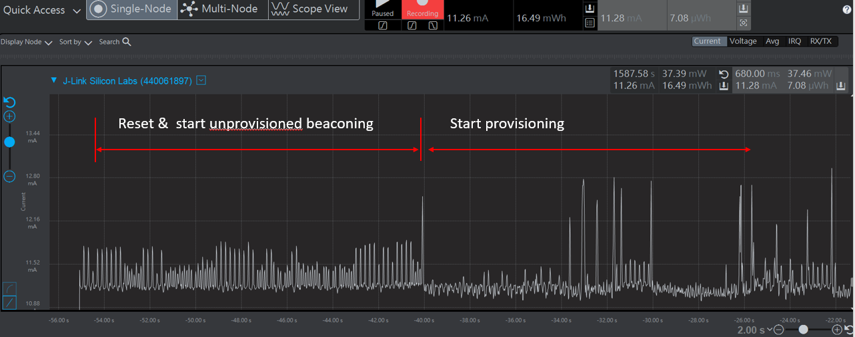

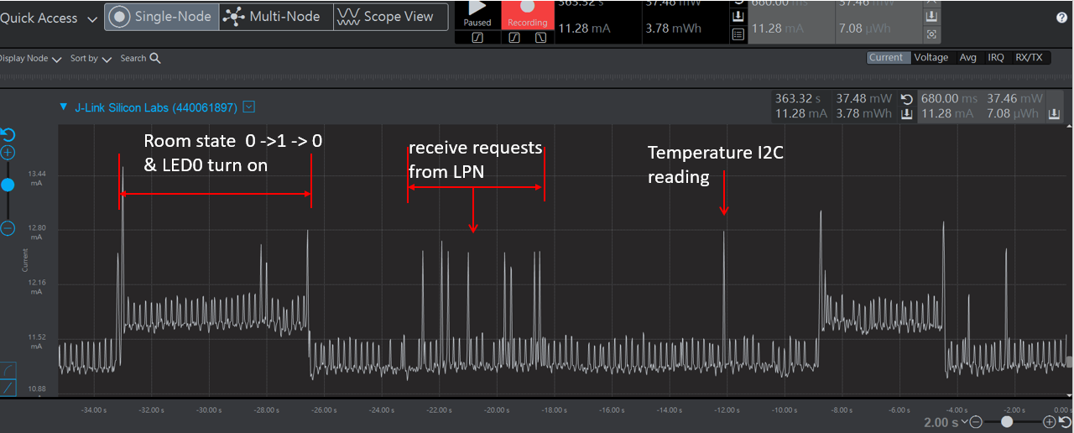

Current profile for state machine without turning on the IR sensors

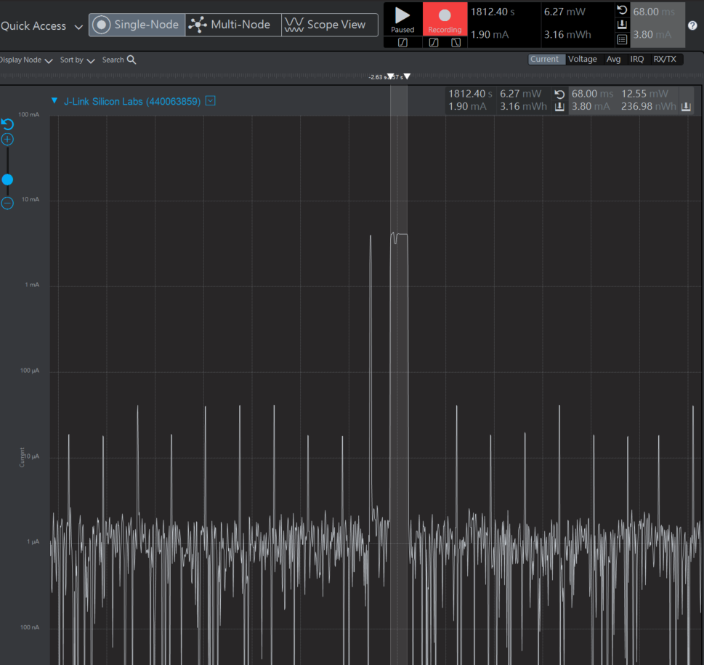

Because the IR sensors should turn on all the time, the average current will be higher. However, the state machine can save power by letting CPU go to sleep during the time interval after sensors complete I2C transfer. Moreover, I2C pins (SDA and SCL) also are disabled by setting GPIO pins. In this way, average I2C energy cost can be reduced dramatically.

***References***

1. Bluetooth LE: Mesh, [https://www.bluetooth.com/what-is-bluetooth-technology/how-it-works/lemesh?utm_campaign=mesh&utm_source=google&utm_medium=cpc&utm_term=trustedtech&utm_content=gaw-october-general-](https://www.bluetooth.com/what-is-bluetooth-technology/how-it-works/le-mesh?utm_campaign=mesh&utm_source=google&utm_medium=cpc&utm_term=trusted-tech&utm_content=gaw-october-general-mesh&mkwid=s&pcrid=227057148453&pkw=%2Bbluetooth%20%2Bmesh&pmt=b&pdv=c&gclid=EAIaIQobChMI1bjU29yK2AIVUZ7ACh3GDQ39EAAYASAAEgItu_D_BwE)

[mesh&mkwid=s&pcrid=227057148453&pkw=%2Bbluetooth%20%2Bmesh&pmt=b&pdv=c&gclid=EAIaIQobC hMI1bjU29yK2AIVUZ7ACh3GDQ39EAAYASAAEgItu_D_BwE](https://www.bluetooth.com/what-is-bluetooth-technology/how-it-works/le-mesh?utm_campaign=mesh&utm_source=google&utm_medium=cpc&utm_term=trusted-tech&utm_content=gaw-october-general-mesh&mkwid=s&pcrid=227057148453&pkw=%2Bbluetooth%20%2Bmesh&pmt=b&pdv=c&gclid=EAIaIQobChMI1bjU29yK2AIVUZ7ACh3GDQ39EAAYASAAEgItu_D_BwE)

1. Silicon Labs Bluetooth Mesh Switch and Light Examples
2. Silicon Labs, <https://www.silabs.com/products/wireless/bluetooth/bluetooth-mesh-introduction>
3. TSL2561 Datasheet -<https://cdn-shop.adafruit.com/datasheets/TSL2561.pdf>

***Links***

1. GitHub Link Project: <https://github.com/CU-ECEN-5823/course-project-TimChien112.git>
2. Command Table link: <https://docs.google.com/spreadsheets/d/11zHdJ1BnmI44b7G3wTKPxPIY7D5X3-DrUN2pKtwDckM/edit?usp=sharing>